**PRESS NOTE**

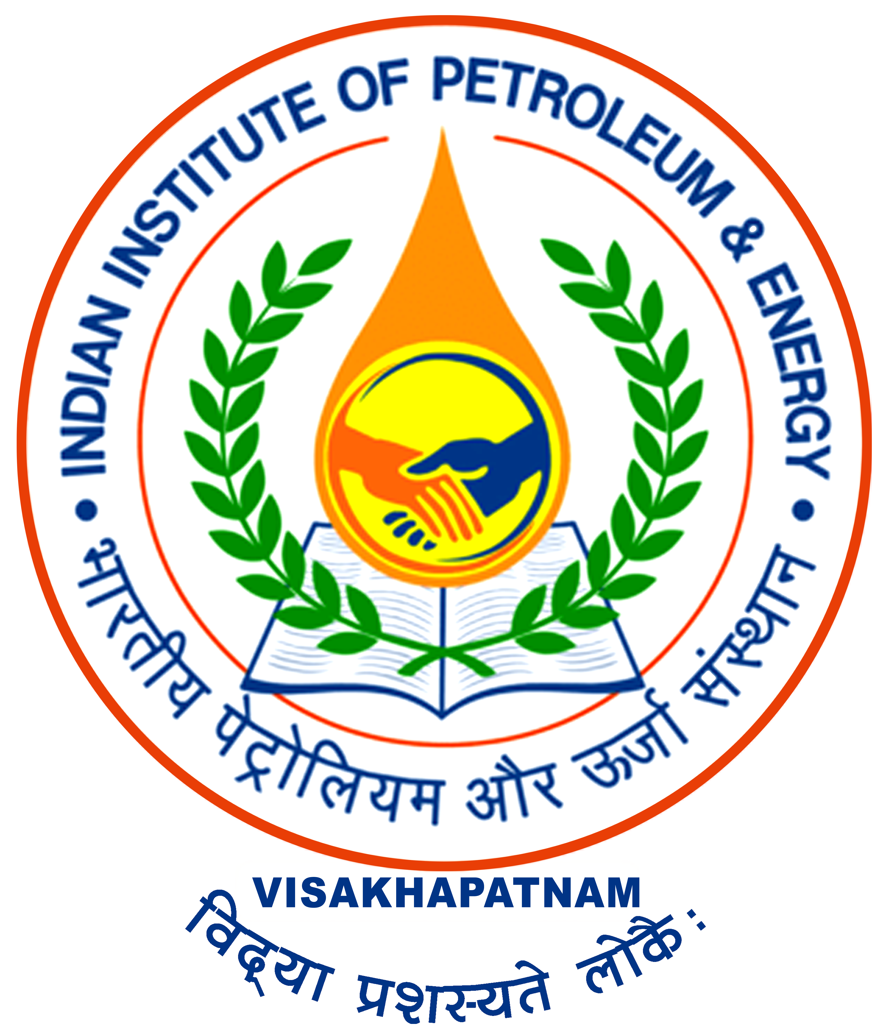

**2nd CONVOCATION OF IIPE**

**Introduction:**

Indian Institute of Petroleum & Energy (IIPE) is established by the Government of India under aegis of the Ministry of Petroleum & Natural Gas, in the year 2016 at Visakhapatnam in accordance with the provisions made in the Andhra Pradesh Reorganization Act, 2014. Initially, the institute was registered under the Andhra Pradesh Societies Registration Act, 2001 and subsequently, the Indian Institute of Petroleum and Energy (IIPE) bill 2017 was enacted by the Parliament. The Indian Institute of Petroleum and Energy Act, 2017 (No. 3 of 2018) declares IIPE is an “Institution of National Importance”.

The institute is co-promoted as an energy domain specific institute by the leading Public Oil PSUs namely HPCL, ONGC, OIL, GAIL and IOCL.

The main objective of establishing IIPE is to meet the quantitative and qualitative gap and supply of skilled manpower for petroleum & energy sectors and to boost the research activities needed for growth of sectors. Also, considering the rapid innovations and developments of new technology in the energy sector and other emerging areas like Shale gas, Coal Bed Methane, Gas Hydrates, Renewal Energy & Gas etc, the IIPE is expected to keep pace with the new developments.

IIPE has collaborated with the leading International Universities such as Texas A&M University, University of Houston, USA, **Petroleum Research Institute of Norway (NFiP), Norway** and other Nationally Important Institutions specialised in the Energy domain. IIPE has also collaborated with IIT Delhi, IIT Madras, IIT Bombay & IIT Hyderabad for student & faculty exchange programs.

**Permanent Campus:**

The Institute is presently operating from its temporary campus situated at 2nd floor, Main Building, AU College of Engineering. IIPE has been allotted the land to an extent of Ac. 201.80 Cts by the Government of Andhra Pradesh, on free of cost, at Vangali Village, Sabbavaram Mandal, Anakapalli District. All pending land issues have been cleared and the construction activities will be initiated shortly.

**Placements:**

At present Institute has taken up its responsibility to extend placements in various Oil PSUs and other noted companies. Placement of the current batch is almost 100%, out of which 75% students got placed in Core Sectors and 25% got placed in Data Analytics and other such sectors.

**New Initiatives**

* The Institute has introduced cumulative contingency and sandwich Ph.D program to promote foreign collaboration.
* Institute has started supporting Undergraduates for attending an International Seminar/ Workshop/Training.
* Institute to host foreign Nationals from one month to twelve months.
* Institute started Summer Internship Programme (SIP). 6 Summer Interns from various institutes across India were selected.
* IIPE has initiated the Group Insurance Policy (GIS) with LIC to provide life insurance coverage to all regular employees.
* Institute has proposed to adopt Rishikonda Beach and is planning to adopt a village.
* Made agreements with local hospitals to provide OPD medical facilities to IIPE fraternity on credit basis as per CGHS rates.

**Recognitions:**

Institute’s Faculty got recognitions from the various National and International level organisations, such as:

1. Prof. Seshagiri Rao Ambati being nominated as a member of the Appraisal Committee (Industry-2), Ministry of Environment, Forest and Climate Change, Govt. of India.
2. Prof. Raka Mandal selected for prestigious SIRE award.
3. Prof. Dipankar Pal selected for Outstanding Research in Chemical Engineering in 8th venus International Science and Technology Award-VISTA 2022.

**Future Perspective:**

The nation has great expectations from us towards achieving the United Nations Sustainable Development Goals (UN SDGs), i.e., ensuring access to affordable, reliable, and sustainable modern-day energy for all and making Pro Planet People.

For fulfilling this responsibility, IIPE is committed to research towards realizing the "Panchamrita" concoction for the climate conundrum, the climate solution offered by the Hon'ble PM, Mr. Narendra Modi, at the COP26 convention in Glasgow.

IIPE facilitates the students to acquire knowledge, helps them develop skills and experience, and cultivates a socially-responsible research mindset.

IIPE is a firm believer in the stakeholders' IKIGAI or a sense of purpose.

Overall, at IIPE, we strive to help foster Blue Zones, enabling a prosperous world to rise like a phoenix from the ashes of today's challenges. Let us play a major role in achieving the goal of an Atmanirbhar Bharat in the energy sector and progress towards 'future ready India @2047'

**2nd Convocation:**

The 2nd Convocation of IIPE is scheduled to be held on 07th September, 2022 from 10:30 AM at VMRDA Children’s Arena, Visakhapatnam. *Ms. Hemalatha Annamalai, Founder and Vice-Chair, Green Collar Agritech Solutions Pvt. Ltd and Founder and Former CEO, Ampere Vehicles Pvt. Ltd.* has kindly consented to be the Chief Guest and will deliver the Convocation address and bless the students on this occasion.

In the present convocation, 87 students (45 students from Petroleum Engineering & 42 students from Chemical Engineering) are being awarded with the degrees. Two students from each branch are receiving the gold and silver medals for their academic excellence.

The institute has extended the invitation to District Authorities (Visakhapatnam & Anakapalli), all Directors & Vice-Chancellors of Universities in and around Visakhapatnam. The CMDs of Oil PSUs & other prominent personalities from Oil & Gas Sector are expected to attend the event.

The program is also live telecasted through IIPE YouTube channel (https://www.youtube.com/watch?v=RvbS3LChEJ8)

Prof. PK Banik, President, Board of Governors, IIPE;

Prof. Shalivahan, Director;

Prof. Deepak Amban Mishra, Associate Dean (Academic Affairs & Administration);

Dr. B. Muralikrishna, Registrar (I/c);

addressed the press conference.

**List of Medal winners**

Institute Gold Medal: Based on highest CGPA in Petroleum Engineering

|  |  |
| --- | --- |
| 18PE10043 | Ms. Kumari Agrani |

Institute Gold Medal: Based on highest CGPA in Chemical Engineering

|  |  |
| --- | --- |
| 18CH10037 | Mr. Chidurala Hruthik |

President’s Gold Medal: Based on CGPA and extra-curricular activities

|  |  |
| --- | --- |
| 18PE10043 | Ms. Kumari Agrani |

SBI Silver Medal: Based on CGPA (2nd highest) in Petroleum Engineering

|  |  |
| --- | --- |
| 18PE10007 | Mr. Priyanshu Agarwal |

SBI Silver Medal: Based on CGPA (2nd highest) in Chemical Engineering

|  |  |
| --- | --- |
| 18CH10001 | Mr. Avik Roy |

|  |
| --- |
|  |